**TRAVEL BUDDY**

**A MINI PROJECT REPORT FOR THE COURSE**

**CB19501 DESIGN THINKING**

***Submitted by***

**VARADHARAJAN S**

**(221401112)**

**SANDEEP VISHWA R**

**(221401081)**

**TATIREDDY DINESH KUMAR**

**(221401102)**

**III YEAR B. Tech**

**COMPUTER SCIENCE AND BUSINESS SYSTEMS**



**Department of Computer Science and Business Systems**

**Rajalakshmi Engineering College**

**Thandalam, Chennai-602105**

**November 2024**

**BONAFIDE CERTIFICATE**

Certified that this Thesis titled “**TRAVEL BUDDY**” is the bonafide work of **VARADHARAJAN S** **(221401112)**, **SANDEEP VISHWA R (221401081)** and **TATIREDDY DINESH KUMAR (221401102)** who carried out the work under my supervision. Certified further that to the best of my knowledge the work reported here in does not form part of any other thesis or dissertation on the basis of which a degree or award was conferred on an earlier occasion on this or any other candidate.

**Student Signature with Name**

1.

2.

3.

Signature of the Supervisor with date

Dr. V. Murali Bhaskaran

Signature Examiner-1 Signature Examiner-2

**TABLE OF CONTENT**

**CHAPTER NO. TITLE PAGE NO.**

**ABSTRACT 4**

**LIST OF TABLES 5**

**LIST OF FIGURES 5**

**LIST OF SYMBOLS, ABBREVATION 6**

1. Introduction
   1. Design Thinking Approach 7
   2. Stanford design thinking module 9
2. Literature Review 11
3. Domain area 12
4. Empathies stage 13
5. Define stage 14
6. Ideation stage 16
7. Prototype stage 19
8. Test and feedback 24
9. Re-design and implementation 25
10. Conclusion 27
11. Feature work 28
12. Learning outcomes 30

Reference 31

* Journal paper
* Website

**ABSTRACT**

Visiting new destinations always a brings in thrill and curiosity, But the challenge is that you have to step into the unknown adjusting to local customs or even looking for reliable information about the place. To solve these “Travel Buddy” is a platform that would help the travellers to connect with locals who are called as ‘buddies’ in our app and well-aware about their city so that the traveller could make most out of their trip.

Firstly, Travel Buddy is all about connecting travellers with real people. When a traveller is looking for something specific, such as hidden secrets about the city, language help or cultural advice, buddies are at their disposal to give that helping hand, making travels an overall easier and more enriching experience. This allows travellers to experience new destinations with more confidence

It also gives the locals who work with it a platform to share their expertise and love of their city. It is giving them a way to make money as they market their community and culture. This end-to-end interchange helps in connecting locals with travellers, benefiting both individuals in turn and as they progress through each other.

It lets you create relationships that last without borders a spot to meet people from everywhere in the world. Made buy travellers for travellers, the platform encloses the gap between those who travel and the destinations they encounter, ensuring each journey is a story worth telling.

**LIST OFTABLES**

|  |  |  |
| --- | --- | --- |
| **S.NO** | **TABLE NAME** | **PAGE NO** |
| 1. | Overview of Design Thinking Stages for Travel Buddy | 10 |
| 2. | Features and Functionalities of Travel Buddy | 18 |
| 3. | Working of Travel Buddy | 22-23 |

**LIST OF FIGURES**

|  |  |  |
| --- | --- | --- |
| **S.NO** | **TABLE NAME** | **PAGE NO** |
| 1. | Stanford Design Thinking Model | 8 |
| 2. | Mind map | 16 |
| 3. | Prototype for Travellers | 19 |
| 4. | Prototype for Buddy | 20 |

**SYMBOLS &ABBREVATION**

1. OTAs - Online Travel Agencies
2. MFA - Multi-Factor Authentication
3. QA - Quality Assurance
4. B2B - Business-to-Business
5. C2C - Consumer to Consumer
6. B2C - Business to Consumer
7. SVG - Scalable Vector Graphics

**1.INTRODUCTION**

Travel Buddy is a service which links tourists to local guides and provides them personal assistance as well as their views that make wandering new lands convenient and rewarding. If you are travelling abroad or a new city, to get some reliable and local advice can help. Enter Travel Buddy, a platform that connects travellers with locals—referred to as buddies—who knows the region well and can offer customized recommendation and assistance on the ground.

The platform makes travellers’ trips more enjoyable and gives locals to offer a piece of their culture, knowledge or skills by creating a source of revenue. Travel Buddy makes these connections meaningful in order to have a real travel experience that travellers could enjoy by having a help from locals sharing the soul of city.

* 1. **DESIGN THINKING APPROACH**

The Stanford Design Thinking Model has been one of the most well-known problem-solving frameworks that are mainly focused on human-centred innovation. It is based on five key stages: each of which has creativity and collaboration as its focal point to produce effective solutions.

Here is an overview of each stage:  
  
**Empathize:** This is the first and the foundational stage where the designers attempt to understand the needs and requirements of the users in detail. The development is meant to acquire insights through observation, interviews, as well as immersion into the environment used by the users into their experiences, challenges, and needs. Building empathy leads to user-centred design.  
 **Definition:** After empathizing, data collected is analysed for defining a core problem. It refers to the synthesis of information and the patterns and framing of the problem in a way that allows it to become specific and focused on action and user. A clear problem statement determines the course of the remainder of the process.  
  
**Ideate:** In this stage, teams come up as many creative solutions as possible. Here the objective is to get as many varied ideas possible without any immediate notions of feasibility. In this phase often brainstorming, mind mapping, sketching exercises or indeed other methods overcomes normal constraints of thinking.  
  
**Prototype:** Prototyping or simple and low-cost representations or models for the product or solution. Prototyping allows one to test ideas rapidly in tangible form, thereby giving hands-on experience and feedback on an outcome.  
  
**Test:** Prototypes are tested here with real users to gather feedback on the work. This is an iterative process which should get to establish work areas that shouldn't be taken. Testing leads to further iterations of the design to refine the solution and meet better needs.  
  
Being non-linear and flexible, it takes the liberty of revisiting earlier stages based on feedback from users or new insights. It focuses on empathy, creativity, and learning by iterations which can be applied in a wide range of fields-from technology to education, and healthcare.

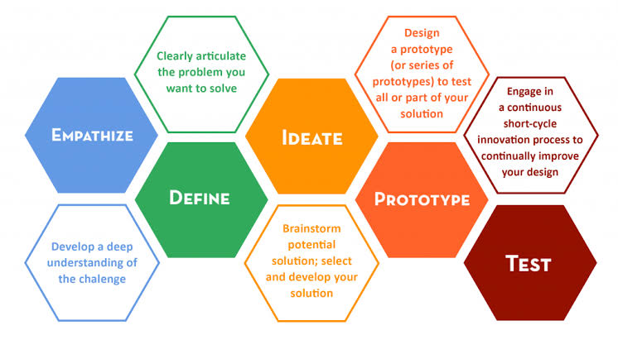

* 1. **STANFORD DESIGN THINKING MODULE**

The Stanford Design Thinking Model is a systematic approach that helps to develop user focused solutions in iterative manner.

**1.Empathize:**

It starts with knowing the voice and buyer persona. This means that Travel Buddy listens to potential travellers and guides to understand the problems they face (e.g. managing their travel plans, attractions or UI pain points). User Research: Phase 1 User research begins with interviews, surveys, user observation to get a more detailed on the experiences and behaviours they unfold there was a time or ends.

**2.Define:**

User problems and needs from discovery of insights gathered. Creating a problem statement that sums up the synthesis of information “Travelers need an easy-to-use system for tracking details of their travel while they need to be able to communicate with guides in a predictable way, all keeping our data secure”.

**3.Ideate:**

Using the problem above, our team brainstorm the ideas. For Travel Buddy that may consist of brainstorming feature-ideas like secure login methods, clean forms for international users or real-time alerts while travelling. Rather, the idea is to look at a variety of solutions that can be applied.

**4. Prototype:**

Travel Buddy will have the prototype with its suggested solutions. These can be anything from simple wireframes of the user interface to mock-ups of the registration process, and even stubs for data entry. Prototyping gives the team a medium to rapidly visualize and test ideas, providing an opportunity to refine designs quickly.

**5. Testing**

The last stage is to give the prototypes to real users and ask for their feedback. Specifically, Travel Buddy has completed usability testing with travellers and guides on multi-factor authentication and country code selection for the phone while running pilots to deal with all UX related issues. It captures feedback, which can be used to identify where improvements are needed and ensure that the platform meets user requirements efficiently.

**1.Overview of Design Thinking Stages for Travel Buddy**

| **Stage** | **Description** | **Key Activities in Travel Buddy** |
| --- | --- | --- |
| Empathize | Understand the users (travellers and guides), their needs, and the challenges they face in the travel ecosystem. | Pain points are best gauged by conducting interviews with potential users, surveys, and field research on issues such as guides' trustworthiness, safety, and ease of planning. |
| Define | Synthesize the information gathered to clearly define the core problems travellers face. | Create problem statements like "How might we ensure safe and verified guide services for single travellers?" |
| Ideate | Brainstorm potential solutions to the defined problems, focusing on user needs and innovative approaches. | Generate ideas that could include a real-time review system, verified local guides, or even tailored trip recommendations using past user feedback. |
| Prototype | Develop a simplified version of the platform to test core features with actual users. | Design low-fidelity mock-ups or wireframes about the most essential features of the platform: guide verification and matching traveller to guide. |
| Test | Test the prototypes with real users and gather feedback on the functionality and user experience. | Pilot the platform among a few users; gather usability, effectiveness, and overall satisfaction with guide-traveller matching and trip planning from such feedback. |
| Re-Design | Based on the feedback from testing, iterate and improve the platform's design and features to better meet user needs. | Based on the feedback, redesign features to include registration, guide verification, and user interface to make it more user-friendly and address concerns about security or efficiency in the application. |
| Implementation | Launch the platform after final modifications, ensuring all key features work seamlessly and meet user expectations. | Deploy the Travel Buddy platform with all essential features, ensuring that all user feedback has been addressed and that the platform is ready for broader use. |
| Learning Outcomes | Reflect on the insights gained from the project, including challenges faced and lessons learned about the travel industry and platform development. | Three key takeaways that sum it all: value of user feedback, security in travel services, the impact of trust in the platform, and some technical learnings on scale. |

1. **LITERATURE REVIEW**

**1. Travel and Tourism in the Digital Age**

The rapid pace of development in digital technology has greatly impacted the travel and tourism industry. Plans, bookings, and even the experience of traveling have undergone such strong evolution. And as many studies show, it is indeed true that digital platforms are central to connecting the traveller with guides, accommodations, and experiences (Buhalis, 2019). More in the direction of custom and flexible options, the traditional travel industry has evolved, with OTAs, mobile apps, and peer-to-peer platforms like Airbnb moving it along. With increasing popularity, travellers are attaching to various platforms that provide contact with local guides or fellow travellers in pursuit of unique experiences, which can be tailored to specific needs and appeal beyond typical tourism packages (Fitzpatrick, 2019). Regarding this shift, the Travel Buddy project therefore takes up offering a platform that connects similarly-minded travellers and guides to curate specific experiences.

**2. Peer-to-Peer Platforms: Definition and Growth**

A host of traditional industries has been revolutionized due to the advent of the sharing economy in travel. Peer-to-peer platforms are an interface that enables users to connect peer-to-peer, bypassing the middleman. Traveling, therefore, becomes an experience which seeks the more localized, authentic experience that online travel platforms like Couchsurfing, Meetup, or even ToursByLocals have created in niches. Further research delves into the fact that aspirations constantly change in the minds of travellers, as they go on to search for authenticity in their immergence with a broad stretch of cultures and communities involved (Richards, 2018). Travel Buddy adheres to this, offering an interface whereby travellers can meet with locals, commonly known as guides, to enhance their travel experience thereby offering customized tourism mentorship and experiences that may not be easily offered by other travel companies.

**3. Tourism Companion Services**

The element of the travel companion has been present in several works but, in most cases, it centers on one backpacker seeking companionship during their travels (Paris, 2017). Social interaction and safety are among the prime movers for travellers who are in pursuit of traveling with companions. Studies also highlight the fact that trust builds up in such platforms as connection with strangers for travel can be concerned with safety and reliability. Thus, Travel Buddy adds verification systems and reviews with the intention of building a trusting relationship between travellers and guides, thereby ensuring a safe and enjoyable experience for all users.

**4. Design Thinking in Travel Platforms**

Travel platforms have shown the application of the design thinking practice as an emphasis on experience, empathy, and development in iterations. In the case of Travel Buddy, the design thinking approach allows for designing and applications of principles such as empathy on user needs and pain points that a traveller is experiencing in real time. As a matter of fact, research favours the notion that platforms which pay more attention to understanding user behaviour and needs tend to increase satisfaction rates as well as involvement among users (Liedtka, 2018).

**5. Sustainability and Responsible Tourism**

Quite recently, sustainability and responsible tourism have been the focus of recent research. A current traveller acquires knowledge not only about destinations but also senses and becomes conscious about the environment, too; thus, desires travel alternatives with the least possible ecological footprints (Gössling & Hall, 2016). Platforms are becoming popular based on low-impact travel and the involvement of the community with the locals. Travel Buddy can develop strategies that promote local guides, allowing it to incorporate aspects of sustainability and protect environmentally friendly travel alternatives such as walking tours or eco-friendly accommodation and cultural immersion.

**Domain Papers**

Tourism domains keep changing. Such change is because of the development of new technologies with the aim of seeking improved user experience. For example, TourVista is a full-web application that aims at making travel planning easier and enhanced. The web application enables Customizable Travel Packages through which customers can have their options customized according to their preferences. It also avails access to Expert Tour Guides. Through the guides, it connects the traveler to the experienced and vetted guides. In addition to that, the system allows for Seamless Hotel Booking, which makes it easier for tourists to make a booking within the system. Its other impressive features comprise Real-Time Weather Forecasting, which gives continuous up-to-date weather information at places they intend to visit and adjust their travel plan accordingly.

A technical approach, TourVista, uses the MERN stack (MongoDB, Express, React, Node.js) for creating an efficient and responsive user interface. This real-time API integration brings forth to the users, a user-centric experience that comes with satisfaction from the user but at the same time shows efficiency in administrative work within tourism. This is the major element to understand why web-based platforms like TourVista are developed not only for travel convenience but to be personalized, dynamic services able to meet the evolving needs of the new traveler.

In this respect, The Virtual Tourist Guide provides an interactive, web-based solution for travelers. The product includes 360-Degree Virtual Tours, so visitors can view destinations with immersive 3D vistas before the trip. The service also uses Location-Based Services, based on GPS data, to provide travel information and navigation about one's immediate location in real-time. With an interface that is user-friendly and cross-device for access to travel services, including the accommodation book and exploration of local attractions, for utmost integration, this system uses the Google Maps API in order to be able to provide flexible and real-time information so that tourists can make informed decisions during travel. The focus is on maximizing both pre-trip planning and options while traveling to make it more economical than other traditional tour guides.

**Design Thinking Papers**

Design Thinking (DT) is increasingly surfacing its role in the resolution of complex, so-called "wicked" problems across sectors including tourism. It is characterized as an iterative, human-centered approach to dealing with problems. The Stanford Design Thinking model has five stages: Empathize, Define, Ideate, Prototype, and Test. This process lets teams develop innovative solutions by focusing on user needs and continually refining ideas based upon real-world feedback. In both TourVista and The Virtual Tourist Guide, DT application ensures that these sites meet the technical requirements in a strict sense but offer fluid, personal experience for the users. For example, in the Empathize stage, the company can be collecting insights from travelers on what ails them in their travel. Definition may be zeroing down to the exact problem: probably lack of local information or maybe an inefficient system for booking.

Prototype and Test stages of DT are very highly applicable for tourism platforms. Creating an early version of the web application and testing it with real users lets developers obtain very important feedback, which would make user interfaces more user-friendly and the overall functionality of the product better. This iterative process is bound to ensure that the final product is user-friendly, highly functional, and appropriate for a variety of different kinds of users. In a nutshell, using Design Thinking gives an innovative practical solution that is user-centered and could fulfill the complex needs of today's tourist, as it forms the backbone framework for tourism-based web applications like TourVista and The Virtual Tourist Guide.

Two innovations - those in the domain, and also in methodology of design thinking- reflect an ever-growing trend toward personalization, efficiency, and real-time solutions in tourism to ensure that travelers have the tools and information available to help optimize travel experiences.

**3.DOMAIN AREA - TRAVEL & TOURISM**

Travel and tourism is an ever-responding dynamic industry continually responding to forces of technological changes and consumer expectations. In this regard, there has been a proliferation of more services, such as Travel Buddy, developed to meet these same aspirations of the increasing demands of travelers seeking hassle-free, personal, and immersed experiences during travels. Personalization, immediacy of data, and fluid interfaces in interacting with the service come into play, thus leading to designing services that meet those needs.

Travel Buddy plans to meet with this trend by providing travel solutions that are individualized. This kind of personalization is derived by using the profiles and preferences of the users, thus enabling the platform to provide destination choices and activities as well as types of accommodations for past behaviors and preferred choices of the users. Integration of live data will enable Travel Buddy to ensure travelers acquire up-to-date information relevant to their destination regarding weather updates, transportation timetables, and other local events. This helps in better decision-making for travelers and changes plans based on the situation when being on the trip. As such, this provides a sense of increased convenience while decreasing stress related to planning a trip.

Travel Buddy offers the strongest user authentication as all data and transactions are included, therefore providing maximum security. In today's cyber world, security is a big issue, and especially in terms of holidays or travel plans where not only personal information but payment details are also in the picture. This is extremely important as, in the digital world, loads of issues concerning hacking as well as other cybersecurity issues are present.

The travel and tourism landscape is going through a new trend with digital and mobile-first solutions becoming the latest trends. Today, the traveler wishes to have all aspects of the journey treated from a single interface, ranging from booking flights and accommodations to arranging local guides and experiences. Travel Buddy meets the said need as it integrates numerous services into one platform that allows tourists to book their tours, hire a local guide, and even find what would interest them locally. This application reduces the dependency of its users on many other applications or websites for help because all these services are provided in one simple interface.

The platform also offers instant notifications as well as updates, which is another efficient feature that can benefit a traveler. For instance, information, such as the delay of their flight, changes in the local weather at the destination, or newly available attractions, can be received by them in real time. This ability to communicate at once with users allows them always to be updated; this adds to the convenience of using the site.

**4.EMPATHIZE STAGE**

In the Stanford Design Thinking model, the Empathize stage is used to make sure that we design solutions from a place of deep empathy with the end users. In case of Travel Buddy, this stage would be to meet different travellers and guides, understand their experiences and what they want & rectifying their pain points.

**Gaining a traveling perspective**

All types of travellers, face lot of complexities while managing travel plans. In the empathize phase, we did extensive user research to better understand what they go through every day. Through our research we determined common issues travellers face included.

**Managing Multiple Bookings:**

Users were irritated by dealing with flights, hotels, and tours that sit in different platforms. We have seen many of these travellers travel Not bearing in Mind significant Information and Facts or having lost their reservation number or wont retrieve it.

Travelers put concern for their data security at a high level when making online bookings. This is a great answer that solves both the former problems and the heavy concerns mentioned above: A platform which can offer ease of use but still with strong security.

**Language barriers and Local Assistance:**

While travelling overseas visitors face a lot of language issues, hence look for platforms which can give them local counselling and help. They wanted an app that would give them access to locals as their guides on the go.

**Interacting with the Guides Community**

The other primary user group, the guides, have their own complicated issues to work through. Travel Buddy interviewed various tour guides in different regions, interviewing them and holding focus groups in the empathize stage.

Many local guides said they had trouble finding customers to market themselves to travellers. Most of the time they operate based on word-of-mouth or use outdated booking systems.

**Communication Issues:**

Just like travellers, guides occasionally have communication issues, particularly when interacting with international visitors. Better tools that enable multilingual real-time communication were mentioned in many manuals.  
Travel Buddy has focused on developing a platform that not only links them with travellers but also helps them to market their services more successfully and keep in touch with their clients regardless of language or location after learning about these pain points straight from the guides.

**Impact of Development**

The development of Travel Buddy is immediately impacted in a few key ways by the insights obtained during the empathy stage. To start, the platform addresses passengers' worries around data privacy by placing a strong emphasis on user security.

**5.DEFINE STAGE**

The Stanford Design Thinking Process’s Define stage is essential for combining insights from the empathize stage and explicitly defining the issues that the platform seeks to address. This phase, for Travel Buddy, converts customer complaints into manageable problem statements to direct the creation of significant fixes.

**Brainstorming for Travel Buddy**

Several core functionalities of the Travel Buddy platform are aimed at making the experiences of the guides and the tourists more beautiful. There is Guide Registration, in which guides must register themselves on the portal, trying to meet a number of conditions. Thus, that way, only those verified and qualified individuals will be providing their services. Each tourist can browse by locality or experience level; view all prices in detail; and, based on this information, make an informed decision while booking a guide.

Another key feature is Travel Buddy-Travel Assistance, where transportation is made available for customers based on the needs of tourists. The type for travel assistance falls under travel buddy. Travelers who need transport assistance can have it available by requesting the service from Travel Buddy. There are diverse types of vehicles in the offer, and the tourists can choose the one that they find convenient for their style or budget of travel. This will incur Separate Charges where the cost will be dependent on the vehicle available; this adds on flexibility as well as customization to the traveller's experience.

The revenue model of the platform is well-designed with the charges of standard time rates for guide services. In Normal Cities, the charge lies between ₹180 to ₹200 per hour. The charge is fairly higher in Metropolitan Cities to ₹200-250 per hour. Such a pricing is sure to keep the platform competitive yet it is capable enough of providing a justifiable payback to guides and extracting value from travellers. Charges for Extended Hours have also been provided. For over 8 hours of services, ₹50-70 is charged per hour. For any long trip for more than 24 hours, the charge can go up to ₹100-150 per hour, following the norms set by the Indian Association of Tour Operators. The model continues to keep the pricing transparent and industry applicable.

**Identifying Key Problems for Travellers**

From the empathize stage, a number of significant issues that travellers frequently encounter surfaced. In order to ensure that the development team can concentrate on fixing the main problems, the following problem statements have been carefully constructed.

**Problem 1: Handling Inconsistent Travel Data**

Travelers need a means to manage all of their reservations for flights, hotels, and excursions in one location. The way things are now done requires customers to switch between different platforms, which causes confusion and inefficiency.

**Problem 2: Safeguarding Information While Traveling**

Because data breaches and insecure systems are common, travellers are worried about the security of their financial and personal information when using online travel platforms.

**Problem 3: Overcoming Communication and Language Barriers**

When visiting foreign destinations, international travellers often struggle with communication. They need a way to easily communicate with local guides in real-time without having to worry about language barriers.

These problem statements draw attention to the particular difficulties faced by travellers, such as the logistical requirement for consolidating travel information and the technical requirement for data protection.

**Defining Problems for Guides**

Travel Buddy aims to tackle the distinct difficulties that guides encounter. We have identified the following important problem statements for guides by examining input from the empathize stage:

**Problem 1: Having Trouble Reaching and attracting Customers**

Guides need a way to effectively market their services to travellers because the platforms they are currently using are either out-of-date or have limitations, which limits their access and visibility to potential customers.

**Problem 2: Inconsistent Employment Opportunities**

During off-peak travel seasons, guides struggle to maintain consistent work, which results in income instability and underutilization of their services.

**Problem 3: Coordinating and Communicating with Passengers**

It is challenging for guides to offer prompt assistance and coordination to foreign visitors because to language hurdles and time zone differences, therefore they require a dependable means of real-time communication.

By identifying these concerns explicitly, Travel Buddy can concentrate on creating features that address these fundamental challenges. Some of these features include a platform for guides to advertise their services, resources for year-round employment, and real-time communication capabilities with support for language translation.

**Framing the Design Challenge**

Defining the design issue in a way that the product team can implement is the aim of the define stage. The difficulties and insights that are discovered are utilized to develop a core design challenge that will direct the ideation and prototyping stages. One way to phrase the Travel Buddy design challenge is:

How might we create a seamless, secure travel management platform that allows travellers to easily manage bookings, communicate with guides, and feel confident about the security of their personal information, while also providing guides with tools to market their services and connect with travellers in real-time?"

**Effect on Upcoming Development**

Travel Buddy's development will be directly impacted by the insights gathered during the define stage. The product team can now start developing particular solutions, such safe login procedures, integrated dashboards for trip reservations, and real-time chat capabilities for guide-traveller contact, as they have a clear idea of the issues and goals.

**6.IDEATION STAGE**

In the Stanford Design Thinking process, creativity is most highly promoted at the Ideation stage. This stage entailed creating possible solutions to the problems that were determined to have been found using the insights obtained from the Define and Empathize stages. The ideation phase of Travel Buddy was engaged in developing a wide range of concepts that meet the needs of guides and travellers alike.

**Value Proposition Statement for Travel Buddy**

**For** tourists traveling to new places (both domestic and international)

**Who** struggle to find trustworthy and knowledgeable local guides, as well as transportation services

Travel Buddy **is a** platform that connects tourists with verified local guides and offers travel vehicle accommodations

**That** ensures tourists have authentic, personalized experiences with easy access to local expertise and transportation options

**Unlike** traditional tour services or random guide bookings,

Travel Buddy offers transparent pricing, secure payments, and verified guide profiles, ensuring a safe, reliable, and culturally immersive travel experience.

**Mind map**

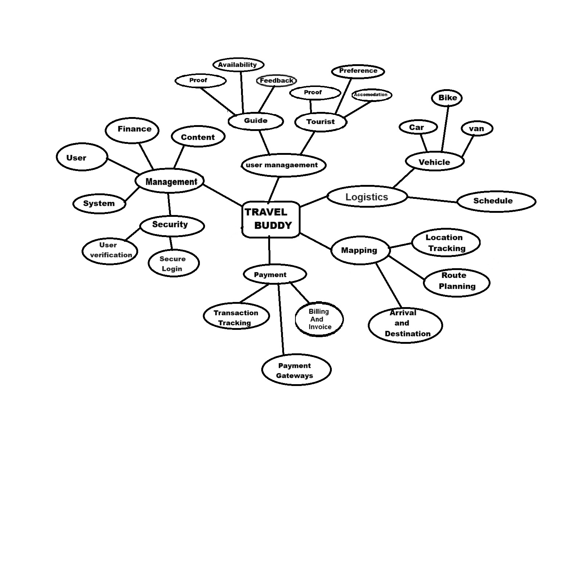

**Travel Solutions Development**

The ideation phase is to find solutions to the major pain points identified earlier when traveling, like managing trip reservations, data security, and the elimination of barriers while communicating with guides locally. One of the most innovative concepts was the centralized trip planner that enables users to manage all reservations-including hotels, and activities-through a single interface.

**Virtual Guide Assistant**

With it, there came the concept of a virtual guide assistant providing language interpretation and recommendations and insider knowledge to the on-the-go traveller. All this information would be available to travellers with no language and communication barrier due to the customized help AI and location-based services would render.

**Ideas on Generating Guides**

For the guides, some ideas developed in the ideation phase involved addressing the issues of marketing services, management of bookings and communication with international clients. Some key ideas that appear to emerge for the guides, among others, are:

**Dynamic Profile Builder:**

A feature call was proposed Dynamic Profile Builder. This feature would enable guides to build profile pages that are visually richer with multimedia - videos and images and reviews and more to attract more travellers to them. So, a guiding principle was to make guides distinct from all others by emphasizing their local knowledge and making it even more personalized to their profile based on services offered.

**Real-Time Availability Tracker:**

Improvement in booking could be made possible by creating a Real-Time Availability Tracker. Guides could update their presence in real-time so as not to double-book events and utilize their time to the fullest. Travelers could view the real-time calendar of the tour guide and make their bookings from there, thereby making the booking process smooth for all.

**Traveler-Guided Review System:**

It is a kind of review system that was proposed to establish trust between travellers and guides. For each of his travels, each traveller would be required to leave reviews. Guides would then have the opportunity to address these reviews and, thus help build their reputation together with improving services according to experiences from such reviews among the travellers.

**Emergency Support System:**

This is a prevalent idea during ideation where the Emergency Support System comes into existence. This facility will provide immediate contact with emergency numbers, safety guidelines, and assistance to visitors while keeping them safe.

**2.** **Features and Functionalities of Travel Buddy**

| **Feature** | **Description** | **Target User** | **Current Functionality** | **Future Improvements** |
| --- | --- | --- | --- | --- |
| Traveller Registration | Allows travellers to create accounts, provide personal information, and set up travel preferences. | Travellers | Simple form with name, email, phone, password. | I added the feature of login through social media, automatic verification, and a guide based on reviews. |
| Guide Registration | Enables local guides to register, list services, and provide verification documents. | Local Guides | Basic registration with verification documents. | Introduce guide certification, instant background checks, and reviews to build trust. |
| Search and Match | Travelers can search for guides based on location, availability, and past reviews. | Travellers and Guides | Search based on location and date. | Add filters like guide language, activity specialization, and price range. |
| Messaging System | Direct communication between travellers and guides to arrange tours and ask questions. | Travellers and Guides | Basic text-based chat with no media sharing. | Add media sharing features (e.g., images, videos) and real-time translation functionality and group chat |
| Review and Rating | Travelers can review guides after a trip, rating them on various aspects such as safety and knowledge. | Travellers and Guides | 5-star rating system, written reviews allowed. | Amplify trusted guides by using weighted ratings, video reviews, and AI-based sentiment analysis. |
| Trip Planning Assistant | Suggests personalized travel itineraries based on preferences and location. | Travellers | Manual itinerary creation by users. | There will also be AI-based itinerary recommendations and automated bookings of accommodation, transport, and guides. |
| Secure Payment Gateway | Travelers can pay for guide services securely through the platform. | Travelers and Guides | Payment processing via third-party service. | Alternatively, local currencies, splitting payments for groups, and travel services integrations, such as with Uber, can be added. |
| Multilingual Support | Supports various languages for international travellers and guides. | Travelers and Guides | Limited language options (English, Hindi). | Provide language support for major global languages and add real-time language translation. |

**7.PROTOTYPE STAGE**

In the Stanford Design Thinking model, the Prototype stage refers to reifying ideas into testable, usable solutions that can be iterated upon. Thus, for Travel Buddy, the prototype stage is focused on low-fidelity versions of key feature implementations that will allow the team to actually envision, test, and refine the actual platform before full-scale development.

**Prototyping for Travellers**

Using what was learned from the empathize and define stages, several features were identified as key for the needs of the traveller. In the prototyping stage, the focus of Travel Buddy is to develop interactive models of the key features:

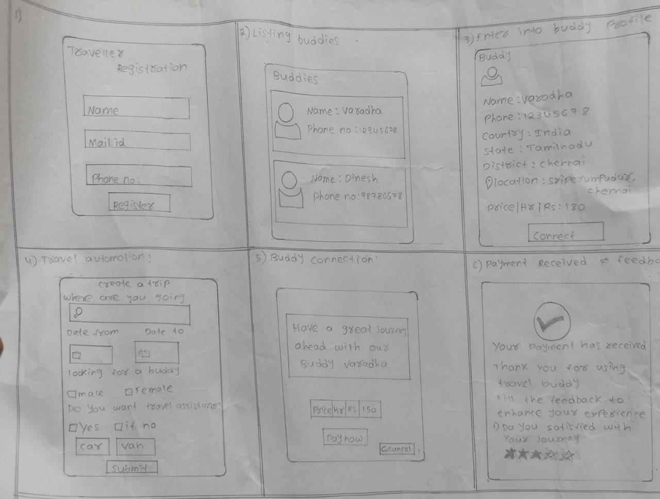

**Centralized Booking Dashboard:**

Another major pain point for travellers is the management of multiple bookings across several platforms. To eliminate this headache, Travel Buddy prototyped a central booking dashboard, where all data on bookings are congregated in a single place. In the interface, a traveller can see hotel reservations, and activity arrangements. Thus, the prototype concentrates on its use with intuitive navigation and easy features, each sufficiently clear in its structure, and with ease with which one can change or cancel bookings.

**Secure Login and Data Protection:**

As the fear of data exposure is in everyone's minds, Travel Buddy really prototypes a secure login mechanism with MFA. This prototype focuses on the usability of users so as to be able to easily register and log into such a system by providing a secure platform for individual information. It has visuals like a password strength meter and, of course, an allowance for biometric authentication that makes the system both usable and safe at the same time.

**Prototyping Solution for Buddy**

At this prototype stage, for guides, their business and operational problems are solved. Developed into some of the must features identified at this stage, they work on prototypes:

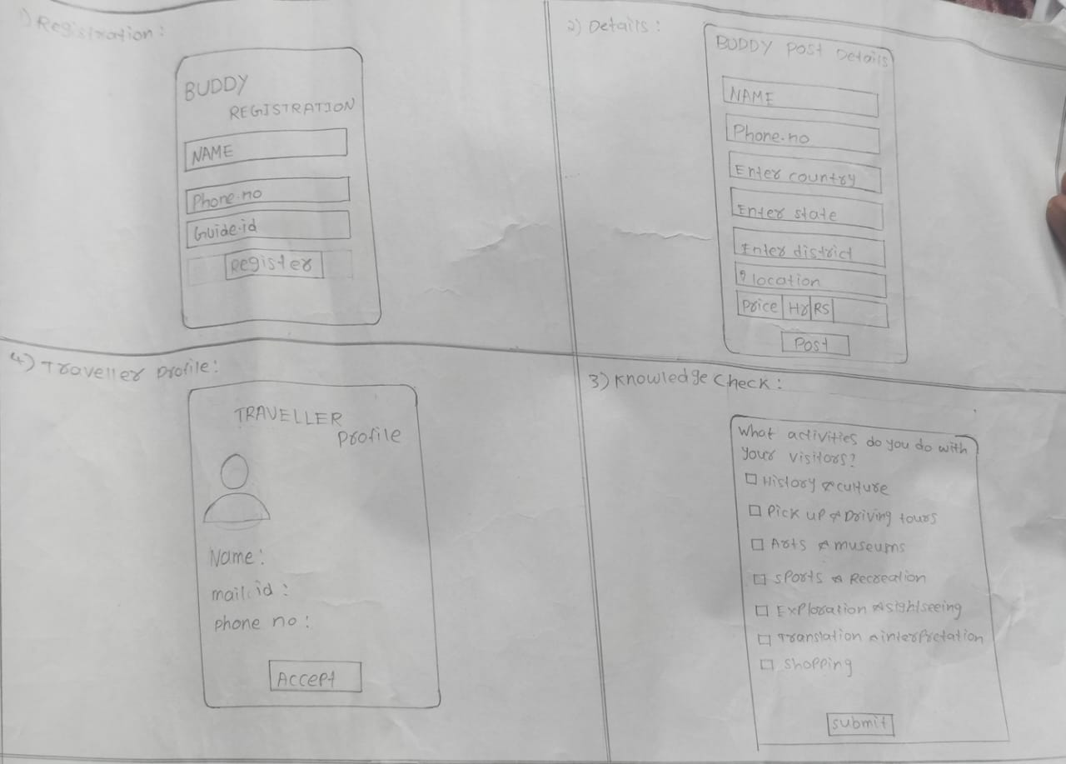

**Guide Marketing and Profile System:**

To make it easier for guides to look for clients, Travel Buddy creates a model profile system where guides can brag about their experience, abilities, and services. The prototype designed allows guides to upload pictures, list tours offered, and include client ratings in past experiences. The design would cover a clean and user-friendly interface by which guides can show their unique offerings in a professional manner for improved visibility of guiding potential clients.

**Guide Booking Management Tool:**

The guide has a booking management tool prototype, which can provide an easy management of bookings. Through it, he or she is able to view the details of the clients and update availability in real time. It may ensure that guides will be organized to respond quickly to inquiries from the traveller. This prototype focuses on simplifying the process or procedure involving the acceptance or refusal of bookings and managing its schedule.

**Low-Fidelity and High-Fidelity Prototypes**

At the prototype level, Travel Buddy creates low fidelity wireframes to describe functionality and flow of all features. Low fidelity wireframes are simple designs, focusing on layout and structure rather than making it aesthetically pleasing. The benefit of this level while testing the usability and navigation of the overall system with potential users is that low fidelity wireframes would be quite useful at this stage. For instance, a central dashboard for the traveller would first be created as a wireframe describing how different sections such as hotels, or activities would be arranged on the dashboard.

Once Travel Buddy gains feedback on low-fidelity prototypes, it moves onto high-fidelity prototypes. These are more refined and interactive, including polished design elements like colour schemes and typography as well as icons. This raises the fidelity of the prototypes so much that users can operate features as if in the final product, thus giving a better output when tested against user needs.

**Prototype Refining**

Prototypes can be amended to become closer to users' expectations through continuous testing and refinement. For example, following the initial feedback on the traveller dashboard, it may emerge that a user is going to want to view all his or her bookings at one time. The team adds a summary section at the very top of the dashboard. Guides may ask for easier ways to modify their profiles, in which case the team is going to simplify the profile editing section interface.

**3.Working of Travel Buddy**

| **Stage** | **Traveller** | **Buddy** |
| --- | --- | --- |
| 1. Registration | - Traveler fills out a registration form - Provides traveller_name, traveller_email, traveller_password, traveller_phone - Verifies email through a confirmation link | - Buddy fills out a registration form - Provides buddy_name, buddy_email, buddy_password, buddy_phone - Verifies email through a confirmation link |
| 2. Profile Setup | Traveler completes her/his profile setup, e.g. profile picture, bio Sets travel preferences and interests | - Buddy creates the profile (profile photo, bio, etc.) - Sets availability and preferences |
| 3. Login | The travellers then input e-mail and password If the details are correct, logs into the system. - If forgotten password, uses recovery options | - Buddy enters email and password  - If all details are correct, log into the system. - If forgotten password, uses recovery options |
| 4. Welcome Tour | -The tourist is taken through a welcome tour or tutorial. -Introduced to core features and navigation | -The buddy is oriented on a welcome tour or tutorial. -Introduced to key features and navigation |
| 5. Dashboard | - Traveler views personalized dashboard - View/edit profile options, view travel plans, check connections - Access to search for Buddies Buddy views personalized dashboard | - Buddy views personalized dashboard  -Link to view/edit profile; manage travel requests; update availability. -Availability to search by Travelers |
| 6. Search & Discovery | -Buddies searched by the traveller based on search criteria (location etc.) and interests. - Surfs through Buddy profiles and sends connection requests | - Buddy looks for Travelers using given criteria, for instance, travel plans or interests. -Analyses Traveler profiles and accepts or declines requests |
| 7. Request/Match | - Traveller sends connection requests to chosen Buddies - Gets notification of connections requests from Buddies - Tracks request status | -Buddy accepts connectivity invitation updates from the Travelers -It reviews and accepts or declines requests. -It tracks request status |
| 8. Manage Connections | - Traveler manages existing connections - Communicates through messaging - Sets up travel plans and itineraries - Can block or remove connections | - Buddy manages existing connections - Communicates through messaging - Updates availability, manages the time schedule - Can block or remove connections |
| 9. Trip Details | - Traveler adds trip details (e.g., itinerary, destinations) - Edits or updates trip details as necessary - Shares trip information with connected Buddies | -Buddy views trip details shared by Travelers - Updates or suggests changes to trip plans - Coordination of information with Travelers |
| 10. Notifications | - Traveler receives notifications for connection requests, messages, and trip updates | Connection requests, messages, as well as trip updates give Buddy notifications. |
| 11. Communication | -Traveler uses messaging feature to convey messages. - Keeps track of conversation history | - Buddy uses the messaging feature for communication -It tracks the history of conversation. |
| 12. Feedback | - Traveller Feedback on Buddy Experience - Rates the Buddy - Can also provide reviews and suggestions - Can also provide reviews and suggestions | - Buddy provides feedback on Traveler experience - Rates the Traveler - Can also provide reviews and suggestions - Can also provide reviews and suggestions |
| 13. Support | - Traveler accesses support for issues or queries - Utilizes FAQs, contact support, or help centre | - Buddy accesses support for issues or queries - Utilizes FAQs, contact support, or help centre |
| 14. Settings & Preferences | - Traveler updates account settings, privacy preferences, and notification settings. | -This up-grades the account settings, availability preferences, and notification settings- Buddy |
| 15. Logout | -Traveler logs out of the system -Session ends and redirect the user to the login page | -The friend logs out of the system -Session ends and the user will be redirected to the login page |

**8.TEST AND FEEDBACK**

It is in the Test and Feedback stage that real users will take the prototypes for validating the design solutions and insights to be provided for further refinement. This stage would be crucial in an interface being built in the ideation and prototyping stages to meet the needs of users and solve the problems well enough. For Travel Buddy, the test and feedback stage is going to check the usability, functionalities, and overall user experience of features offered on the platform by both travellers and guides.

**Testing with Travellers**

Testing with travellers focuses on evaluating how well the platform's features address their key needs and pain points. The process will involve a number of steps:

User testing sessions, the primary feature prototypes are tested on the travellers in user testing sessions. The prototypes vary from a centralized booking dashboard to a secure login system and real-time communication tools. In the session, the travellers are asked to perform specific tasks like booking a trip, accessing their travel documents, or initiating a chat with the guide. Testing with Guides

**Testing with Guides**

The testing with guides focuses on ensuring that the features developed to support their needs are effective and user-friendly. Major activities in the process entail:

**Scenario-Based Testing:** Presents scenarios to the guides that reflect real-life tasks they will carry out on the platform. These include updating their profiles, managing bookings, and communication with travellers. Through this simulation, the team is able to understand whether the needs of the guide are met appropriately and note any usability issues.

**Feedback Collection and Analysis**

All feedback in testing is really crucial to be improved on the platform. Among those processes, following ones deserve a mention:

**Feedback Analysis:**

It refers to processing that includes looking at what themes or what issues are particularly common on the feedback. Thus, it means analysing the common pattern-whether its usability related, functionality related, or user-experience related-and then organizing the feedback into related departments, such as booking modifications and usability, as discussed above.

**Satisfaction of the User and Improvement**

The test and feedback stage aims at the satisfaction of the user and at continuous improvement of the platform. The characteristics of this step comprise:

User Satisfaction Surveys: Surveys are conducted to evaluate general user satisfaction with the platform. Questions are designed with focus on how well the feature set meets the needs of the user, its friendliness, and overall experience. High ratings for satisfaction clearly indicate that the platform is effectively addressing the needs of the users.

**9. RE-DESIGN AND IMPLEMENTATION**

The solutions gathered previously and the feedbacks gathered are used to finalize any final adjustments before its proper implementation during this Re-design and Implementation stage. This makes a strong product in terms of user-friendliness and makes it robust with the thoroughness of proper deployment.

**Re-design Based on Feedback**

This is the phase that will make sure users' feedback from the test phase has been incorporated into redesign to improve functionality and usability of the platform. The process includes:

**Iterative Design:**

"Redesign" means that this process is iterative. It involves incrementally changing things and then repeating testing to make sure that the problems are well covered. In this case, it includes updating of prototypes, the extra rounds of user-testing, and refining based on the new feedback. For example, if the first redesign of the booking dashboard still has critical usability problems, then further refinements are made iteratively until this interface is deemed to be in line with expectations by users.

**Implementation of Final Design**

Once the re-designing is performed, then the ultimate design is put into a workable platform. Several key activities are associated with it:

**Development and Coding:** The ultimate design is realized as an executable product in development and coding. It involves development of all the features of a platform, integration of all those into a structured system such that all the functionalities work together seamlessly. For Travel Buddy, this would include development of backend and frontend elements, including booking management, secure login mechanisms, real-time communication, and much more.

**System Integration:**

This relates to ensuring that different parts of the platform can seamlessly work with each other. It includes connecting user interface elements with a backend database, third-party services, and the proper flow of data, whether into or out of the different components of the system. For instance, a centralized booking dashboard might need integration with the database so that it can query in real time for booking information which then updates the profiles of the users.

**Quality Assurance (QA) Testing:**

QA testing involves discovering bugs or anomalies and resolving them before launching the platform. This might involve feature or functional testing, where all the features should work without any issues; performance testing, or checking how reliable the system is when a lot of loads is put on it; and security testing, which emphasizes the platform's ability to ensure user data is secure and safe. For Travel Buddy, it would entail testing its functionality-those related to alteration of bookings and secure storage of documents-to know that they are good and stable.

**User Acceptance Testing:**

A set of end-users would test the final version of the product to test its readiness for release before it meets the expectations of the users. This stage is very important in terms of validation on whether the product is ready for launch and if all problems or concerns identified have been addressed.

**Deploy:**

The platform is then available to users for deployment in the production environment. This means that users have to set up a server, configure cloud infrastructure, and ensure that any given platform has become accessible and scalable. It would mean that you take your application and deploy it to a live server so that it could handle user traffic well for Travel Buddy.

**Marketing and User Onboarding:**

Marketing activities will be carried out in order to popularize the platform and attract users upon its launch. For Travel Buddy, this will include the development of marketing campaigns as well as guides and tutorials in user manuals in order to assist both the travellers and guides when using the platform.

**Monitoring and Support:**

Given the mission, one soon realizes that continuous monitoring and support become indispensable for making sure that the platform will perform well and be able to overcome potential issues that could pop up after launch. For Travel Buddy, this includes setting up monitoring tools, setting up a support team, and ensuring that matters are promptly addressed.

**Continuous Improvement**

The re-design and implementation stage also sets the platform for continuous improvement. Following its launch, the platform is always under scrutiny in terms of any aspect in need of improvement as a result of user feedback. Key activities include:

**Post-Launch Feedback:**

The feedback from users who start using the platform gives a sense of what is still required to be improved. All the gathered feedback is used for iterative updates and improvements on the platform. If, for example, new feature requests or usability issues are reported, these are prioritized to improve the platform for the next update.

**Performance monitoring:**

The performance of the system is continuously monitored, thus keeping the platform reliable and efficient. Issues regarding speed, scalability, and stability are identified through performance metrics and solved accordingly.

**10.CONCLUSION**

In developing Travel Buddy, dealing with headwinds that surprise is actually the heartbeat of this success project. The essential takeaways include:

**Proactive Problem Solving:** Issues were quickly resolved in order for things to move freely and to address user needs.

Iterative improvement with feedback resulted in continuous refinement, always striving to improve functionality and experience on the platform.

**Collaborative Effectiveness:** Clear communication and teamwork were the prime factors in maximizing effective problem solving.

**Adaptability:** Flexibility and resilience over problems kept the project momentum going.

**11.FUTURE WORK**

For our project Travel Buddy, future work includes a whole spectrum of enhancements and features that will improve user experience and platform capabilities. Among these are some of the followings:  
  
**1. Improved Matching Algorithm**  
Use AI-based algorithms to perhaps improve better matching between the traveller and guide, possibly on the grounds of preference, travel history, and also activities they might be interested in. The algorithm used would be one in the machine learning stream that improves suggestions over time. This way, for instance, the experience gets personalized for the user.

**2. Integration with Travel Services.**  
Connect APIs of the most commonly used travel service providers or booking websites such as hotel booking, flight booking, or local transportation, for example Uber or Airbnb. This will make a traveller to book even more through single interface and thus make it more convenient.

**3. Enhancement on Multilingual Support**  
Currently, the platform allows only limited acceptance of languages, though future releases will include more global languages with real-time translation capacity to make the site friendlier to the worldwide audience who are traveling and guiding.

**4. Review and Rating System**  
The review system can be worked upon to add more precise categories, such as safety, knowledge, friendliness, etc. Video reviews and traveller's testimonials or guide badges for top-rated guides should be incorporated to make the system more rewarding and richer feed for new users.

**5. AI-Powered Chatbots for Customer Support**Better customer support would be offered to the customers if AI chatbots which can solve common traveller and guide queries instantly were implemented. These would help solve booking problems, payment questions and other questions that a user would want clarification on in respect of their trips.

**6. Offline Support for Travellers**Add an offline reach functionality so travellers can have access to a guide's description, itineraries, and maps even when the internet connection is a problem in a particular area.

**7. Community Engagement of Travellers**Create community features such as forums or social media sharing platforms so the traveller can share his travel experiences and ask for tips from other users. This will also give great user culture around the Travel Buddy platform.

**8. Security Enhancement**  
Transactional and user information should be encrypted as well. Implement two-factor authentication on log-in.

**9. Guide Certification and Training Programs**  
Implement a certification program for guides with defined standards on both quality and experience level. Provide additional training resources as optional.  
  
**10. Collaboration with Local Tourism Boards**Develop partnership with the local tourism boards or even governments to encourage local culture and under-explored hidden gems. This will increase tourism in areas less explored and give experiences travellers would rather not find elsewhere.

**12. AR/VR Travel Experiences**  
The integration of AR or VR in the future will enrich the pre-trip experience. Travelers will be able to investigate their destination locations in advance, while the guides will provide immersive experiences during the trip.  
All these new and enhanced features will put Travel Buddy at a competitive edge in the travel and tourism market, which continues to evolve to meet new needs among not only travellers but also among guides.

**12. LEARNING OUTCOMES**

Travel Buddy Learning Outcomes Learning Outcomes is the reflection on key insights and lessons learned throughout the development of Travel Buddy. This is very important in the development process as it will be used to understand what impact a project can have on its stakeholders and identify areas needing improvement while applying those to future projects. It captures all the experience accumulated along the several phases of the project, from research up to the implementation phase, and finally the user feedback.

**Understanding the Needs and Problems of the User**

Developing Travel Buddy with deep learning outcomes, not only for understanding what the user requires but also for every challenge that a traveller or a guide might face in making this application.

Some key pain points were brought to light, particularly regarding hassle in dealing with multiple bookings, concerns over data security, and a bit of issues regarding communication with the local guides. Given the user-centric nature of the needs of the project and including features such as Centralized Booking Dashboard and among others, meeting those needs meant taking a user-centred approach to design.

**Why User Feedback?**

It was clearly learned through this process of design thinking that user feedback is at the heart of any end product development. The main takeaways are:

**Worth of Testing:**

Real user testing provided some crucial input about whether well the features meet the need. The feedback of the traveller and guide accounted for some vital refinements; hence it ensured the platform will be intuitive, functional, and even aligned to the expectations of the user.

**Ongoing Improvement:**

The project demonstrated that continuous improvement is necessary for success. The constant update and iteration based on user feedback were good ways to address issues, improve on features, and adapt to ever-changing user needs.

**Empathy and User-Centric Design:**

In the Empathize stage, it became very important to understand what users required from them. This user-centricity was foundational in informing which features were considered for designing and developing them directly from the pain points and needs of users.

**Learning Outcomes from Design Thinking**

The aim of the course is that, upon its end, students have mastered the Design Thinking process itself and its five key phases: empathize, define, ideate, prototype, and test. Immersion activities can be learned to create empathy maps that would help in deep understanding of user needs. Students will learn skills for defining key problems based on user personas and apply ideation techniques to create creative solutions.

Further, they are going to develop prototypes centered on value propositions, which they can test and come back with the feedback in order to ensure that it all works properly to answer the needs of the user. It is an extremely practical course that teaches how to translate theories into something innovative and user-centered.

**REFERENCES**

**Journal Papers**

[1] Tour Vista: Tour Guide Web Application H. M.C.H. Karunathilaka

1, J.A.M.P. Jayasinghe2, W.M.A.S. Gunasekara3, W.T.R.P Fernando4, D.I. De Silva5, M.P. Gunathilaka6

[2] Comparative Study of Tourism Websites in India – With special reference to South India Dr. Kavita Chavali and Dr. Subrat Sahu

[3] A STUDY ON THE CONCEPTS OF DESIGN THINKING Mrs. P. Deepa

Assistant Professor, MBASRMIST Ramapuram, Chennai, Tamil Nadu, India

[4] Design Thinking: A Review PaperVikas T N1, Vinay C T2, Habeeba Amrutha Hegaddathy3, Rizwan N Shaikh4, Mrs. Vidya5

**Websites**

1. Buhalis, 2019 – Digital transformation in tourism and hospitality:  
   <https://journals.sagepub.com/doi/10.1177/14673584231198414>
2. Fitzpatrick, D. (2019). The Future of Travel: How Technology is Changing the Way We Explore the World - <https://www.theguardian.com/haval-ultra-hybrid/2023/feb/03/the-road-to-the-future-how-tech-is-changing-our-everyday-lives>
3. Paris, J. (2017). Solo Travel Companions: A Qualitative Study of Motivations, Experiences, and Challenges - <https://www.researchgate.net/publication/346452536_What_motivates_and_hinders_people_from_travelling_alone_A_study_of_solo_and_non-solo_travellers>
4. Gössling, S., & Hall, C. M. (2016). Tourism and Sustainability: Development, Impacts, and Management - <https://www.routledge.com/tourism-hospitality-and-events/tourism/tourism-developmentimpacts>
5. Couchsurfing: <https://www.couchsurfing.com/>
6. Meetup: <https://www.meetup.com/>
7. ToursByLocals: <https://www.toursbylocals.com/>